# Sign up - doctor

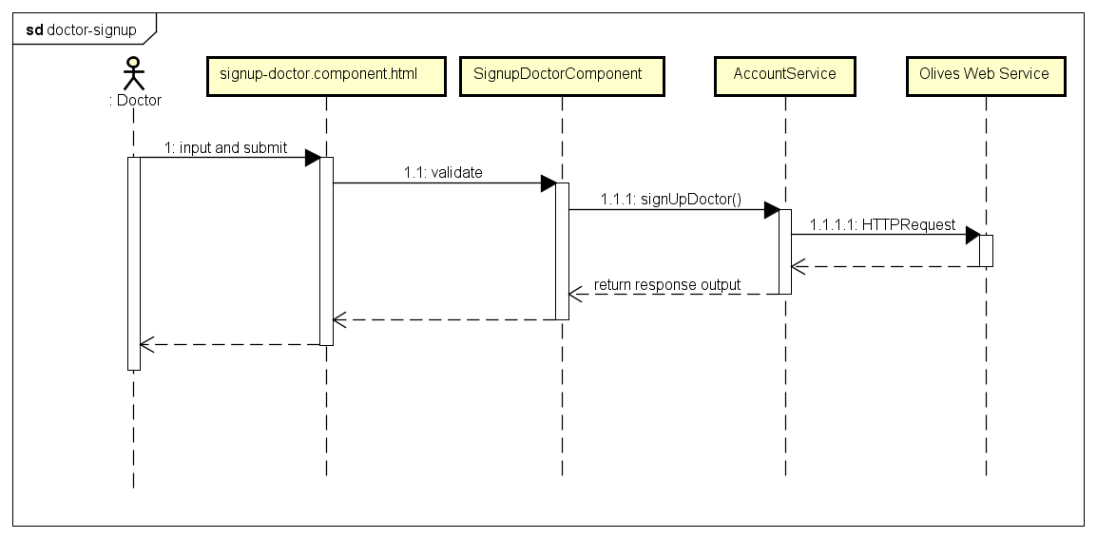

# Sign up – patient

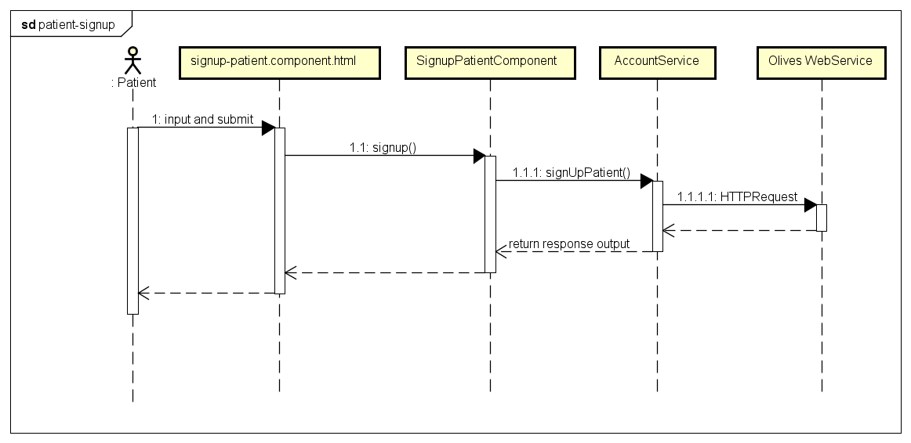

# Sign in

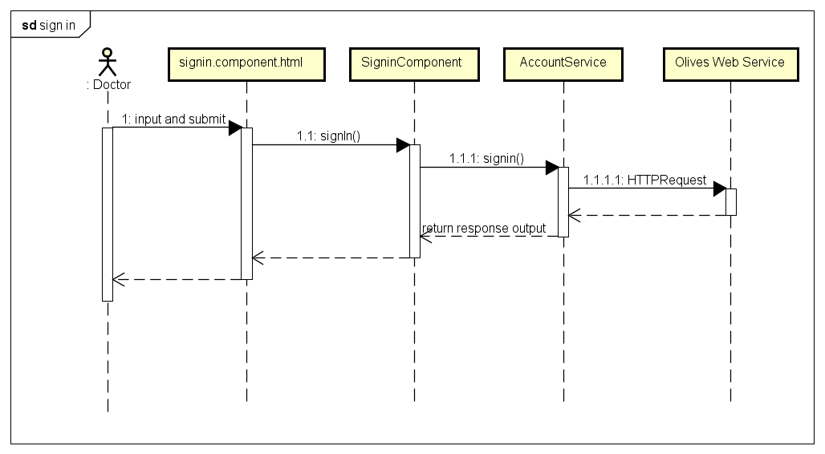

# Sign out

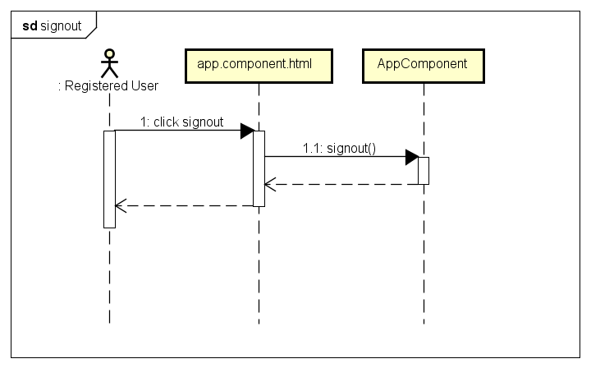

# Forgot password

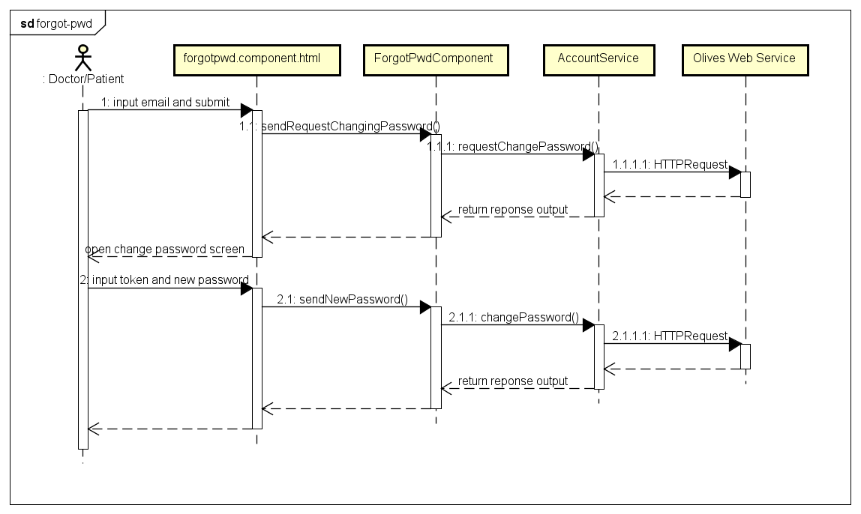

# Notification

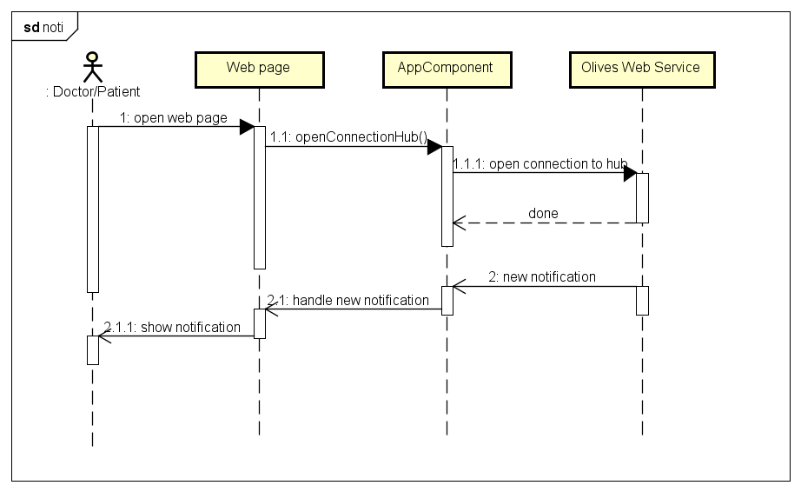

# Chat

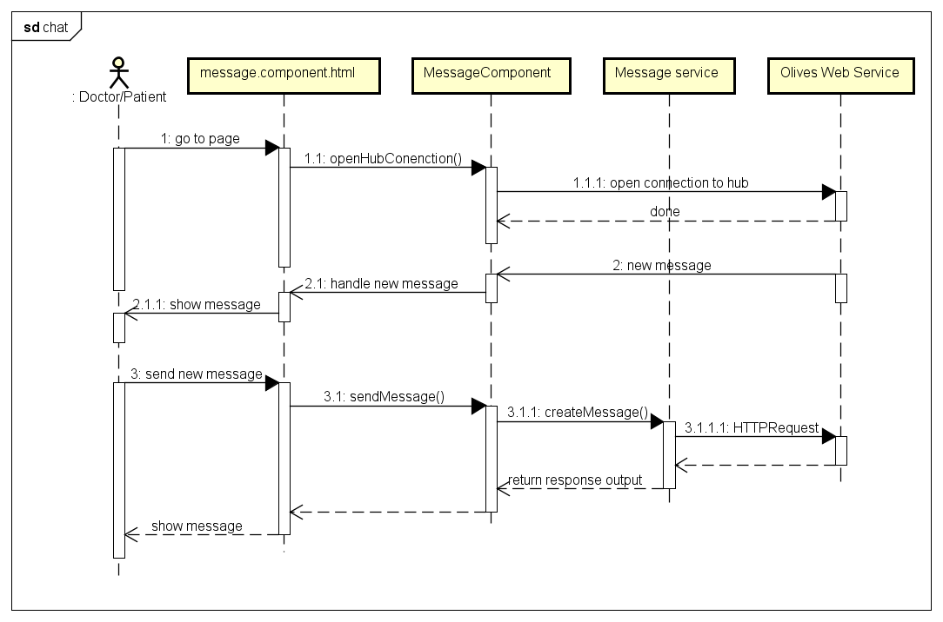

# Get/ Filter

|  |  |
| --- | --- |
| **Doctor** | |
| No | Name |
| 1 | Get activated appointments |
| 2 | Get pending appointments |
| 3 | Filter appointments |
| 4 | Filter medical records |
| 5 | Filter medical notes |
| 6 | Filter medical experiments |
| 7 | Filter medical images |
| 8 | Filter prescriptions |
| 9 | Filter patients in relationship |
| 10 | Filter diary for specific patient |
| 11 | Filter medical records for specific patient |
| 12 | Filter messages with specific patient |

|  |  |
| --- | --- |
| **Patient** | |
| No | Name |
| 1 | Get activated appointments |
| 2 | Get pending appointments |
| 3 | Filter appointments |
| 4 | Filter medical records |
| 5 | Filter medical notes |
| 6 | Filter medical experiments |
| 7 | Filter medical images |
| 8 | Filter prescriptions |
| 9 | Filter doctors in relationship |
| 10 | Get all allergies |
| 11 | Get all addictions |
| 12 | Get all blood pressure records |
| 13 | Get all blood sugar records |
| 14 | Get all heartbeat records |

General

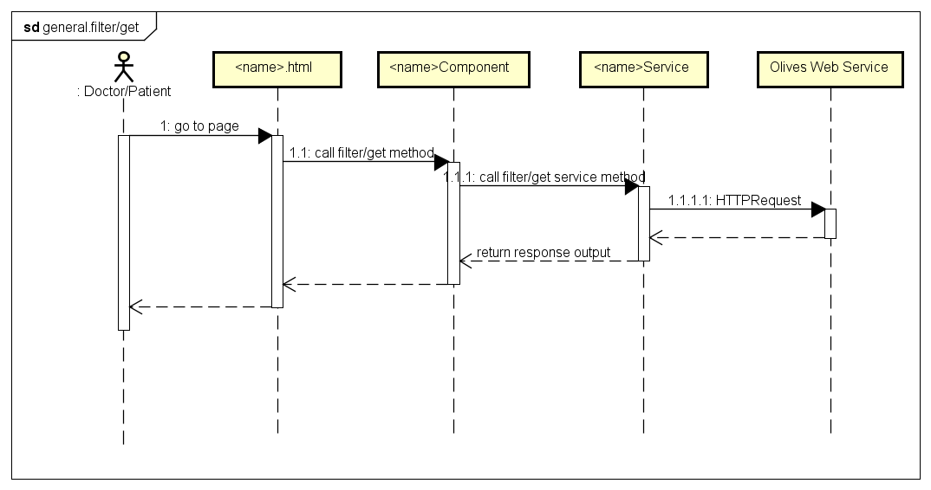

1. Filter pending appointment

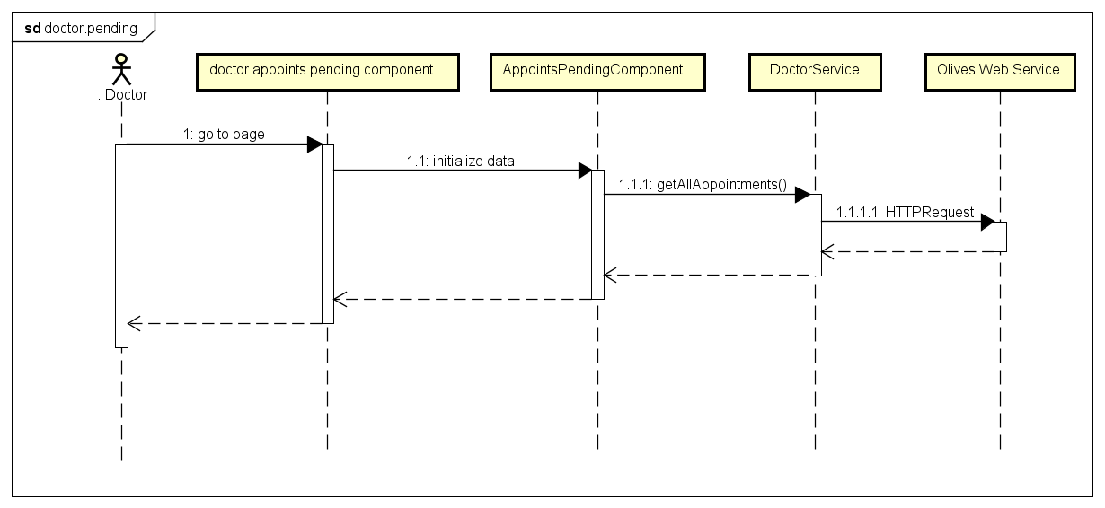

1. Filter medical record

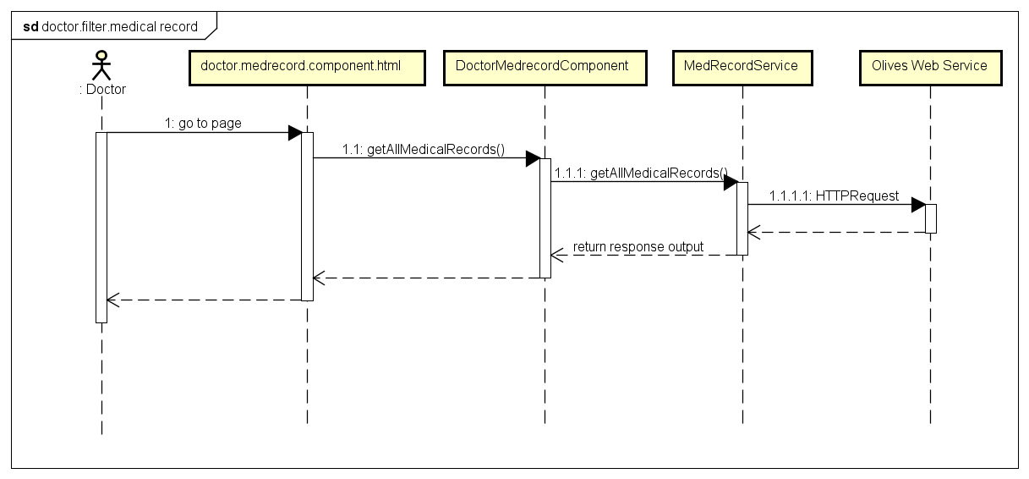

# Create/Add

|  |  |
| --- | --- |
| **Doctor** | |
| No | Name |
| 1 | Create appointment |
| 2 | Create medical record |
| 3 | Create medical note |
| 4 | Create medical experiment |
| 5 | Create prescription |
| 6 | Create medical image |
| 7 | Create diary for specific patient |

|  |  |
| --- | --- |
| **Patient** | |
| No | Name |
| 1 | Create appointment |
| 2 | Create medical record |
| 3 | Create medical note |
| 4 | Create medical experiment |
| 5 | Create prescription |
| 6 | Create medical image |
| 7 | Create allergy |
| 8 | Create addiction |
| 9 | Create blood pressure record |
| 10 | Create blood sugar record |
| 11 | Create heartbeat record |
| 12 | Add doctor relationship |

General

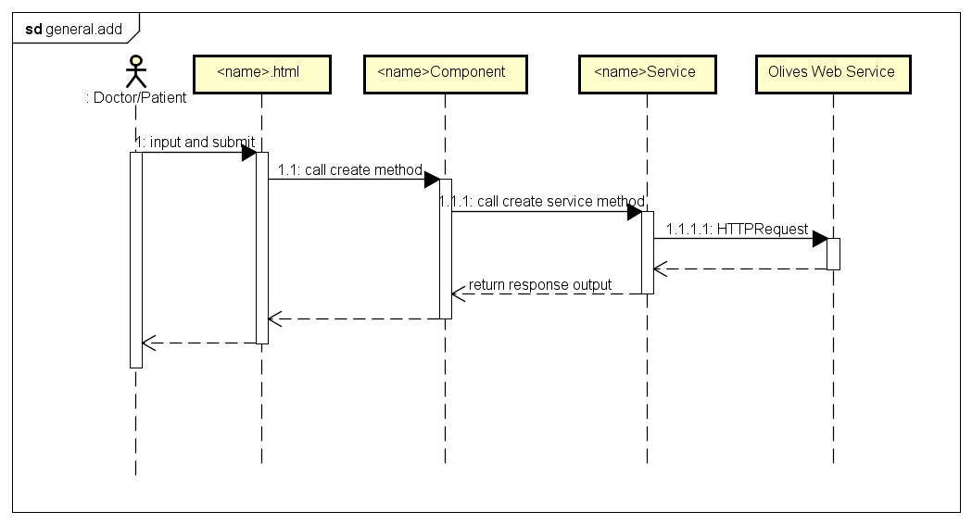

1. Create appointment

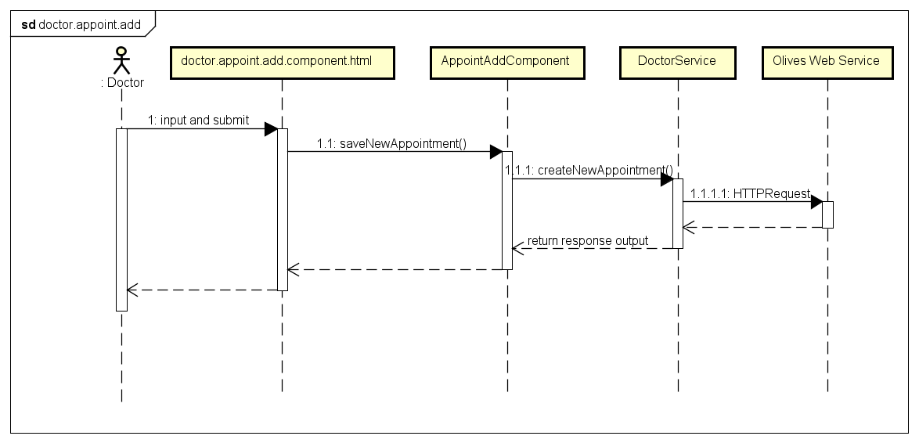

1. Create prescription

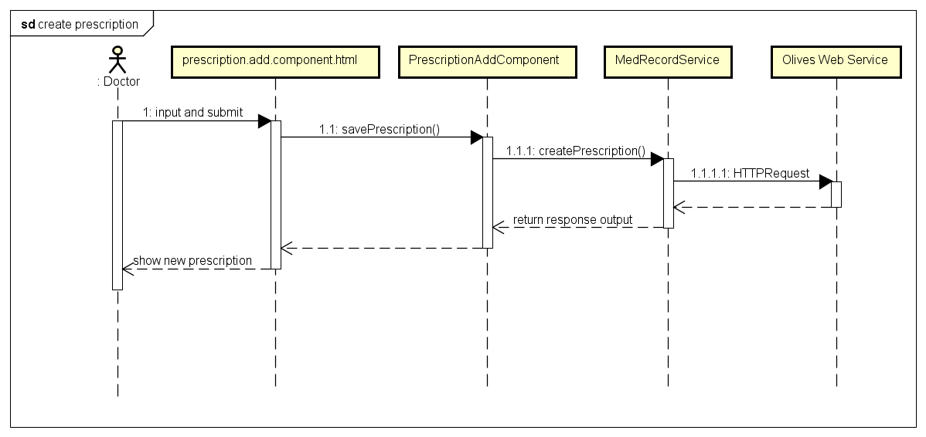

# Update

|  |  |
| --- | --- |
| **Doctor** | |
| No | Name |
| 1 | Update appointment |
| 2 | Update medical record |
| 3 | Update medical note |
| 4 | Update medical experiment |
| 5 | Update medical image |
| 6 | Update prescription |
| 7 | Update diary of specific patient |
| 8 | Update profile |

|  |  |
| --- | --- |
| **Patient** | |
| No | Name |
| 1 | Update appointment |
| 2 | Update medical record |
| 3 | Update medical note |
| 4 | Update medical experiment |
| 5 | Update medical image |
| 6 | Update prescription |
| 7 | Update allergy |
| 8 | Update addiction |
| 9 | Update blood pressure |
| 10 | Update blood sugar |
| 11 | Update heartbeat |
| 12 | Update profile |

General

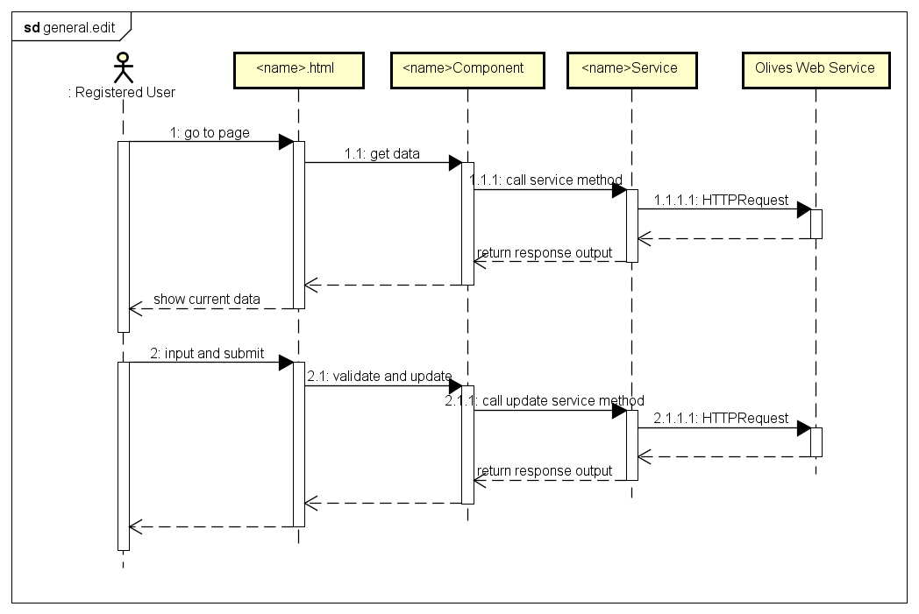

1. Edit appointment

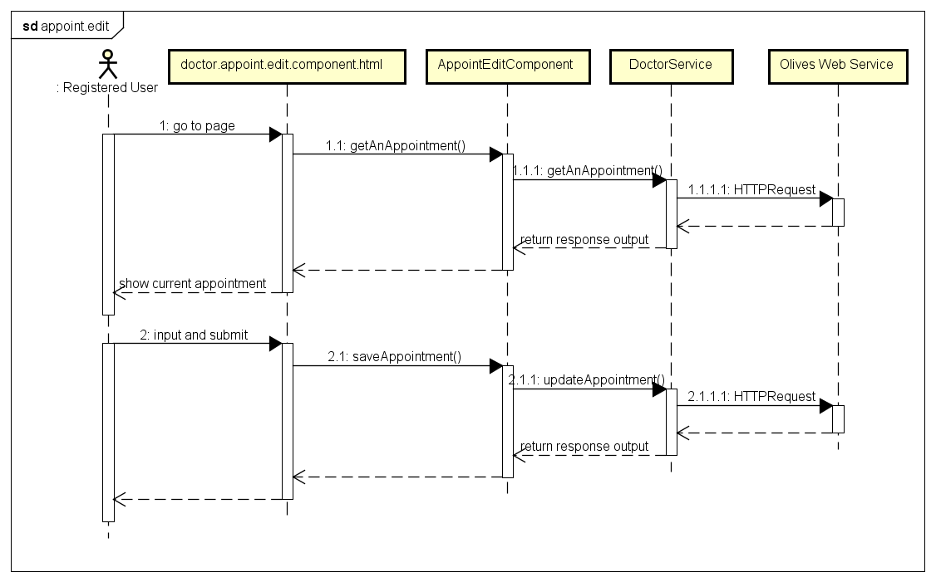

1. Edit prescription

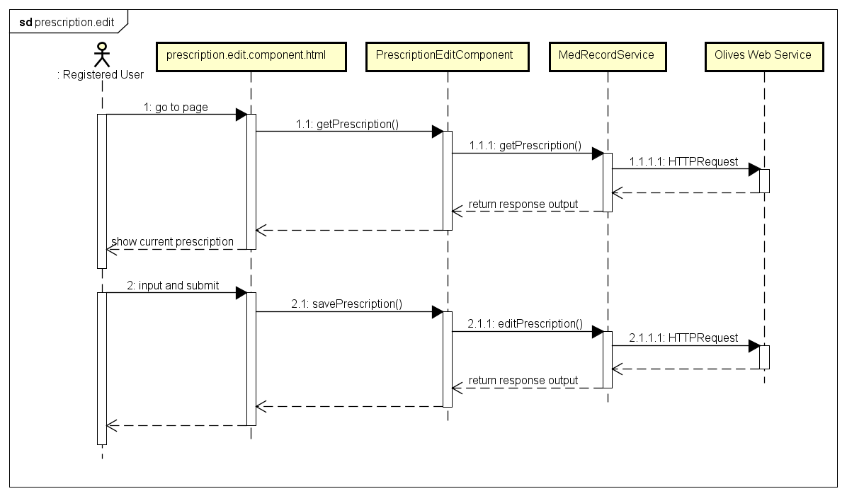

# Delete

|  |  |
| --- | --- |
| **Doctor** | |
| No | Name |
| 1 | Delete diary |

|  |  |
| --- | --- |
| **Patient** | |
| No | Name |
| 1 | Delete allergy record |
| 2 | Delete addiction record |
| 3 | Delete blood pressure record |
| 4 | Delete blood sugar record |
| 5 | Delete heartbeat record |
| 6 | Delete medical record |
| 7 | Delete prescription |
| 8 | Delete medical note |
| 9 | Delete medical experiment |
| 10 | Delete medical image |

General

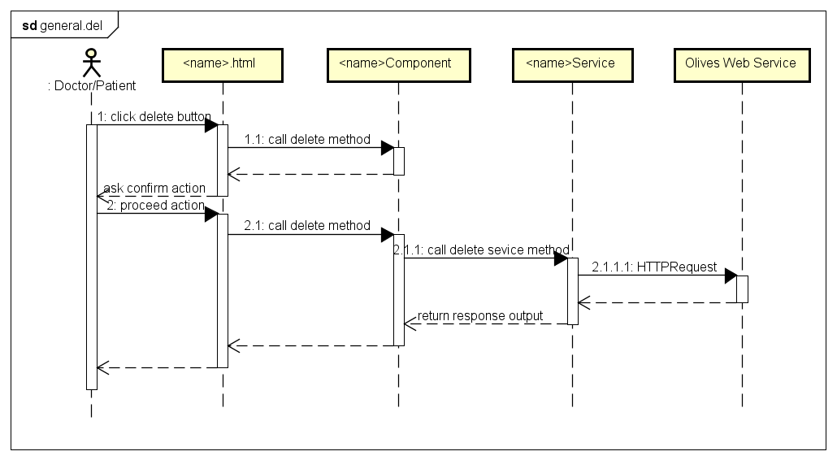

1. Delete prescription

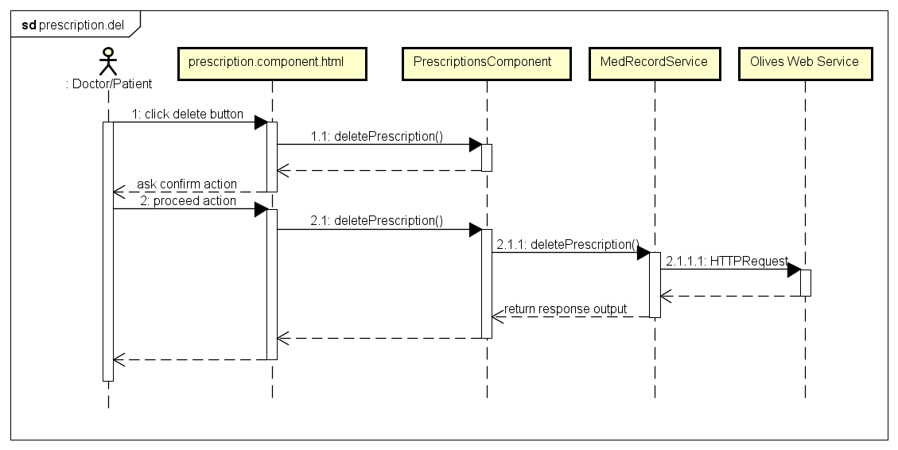

1. Delete diary

